[1]

Aparna N. Shendkar, Ayush Sahare, Samruddhi Shinde,   
Sanskruti Ruyarkar, Sameer Sangewar, Samyak Malame, Aditya Sankpal

**Department of Engineering, Science and Humanities (DESH)**

**Vishwakarma Institute of Technology, Pune, Maharashtra, India**

Abstract — (in 250 words) *Personal management of finances is more important nowadays in the digital economy, particularly for students and individuals with weak financial literacy. Traditional methods of tracking expenses, including notebooks or spreadsheets, are not only time-consuming but lack analytical capabilities and a graphic-friendly interface. This article presents a browser-based, HTML-based expense tracking system with CSS and JavaScript that is user-friendly, responsive, and accessible on any device without any backend installation and infrastructure requirements. Users can enter, categorize, and list their day-to-day transactions and provide real-time feedback in the form of dynamic pie charts using the Chart.js library. The data visualization allows users to instantaneously observe their expenses and maintain control of their budget0. The simple UI and real-time data visualization significantly enhance ease of use and encourage regular financial checking. Unlike AI-heavy sites depending on advanced backend logic and server computation, this app focuses on client-side implementation for the sake of prompt response, usability, and data privacy. Modelled after modern expense tracking software that merges visual reporting and automated categorization for the purpose of facilitating user-based financial activity, The live project on GitHub Pages is a demonstration of the use of pure front-end technologies in this manner to solve real-world problems in personal finance. Enhancements down the road could include local storage, income comparison dashboards, and receipt scanning using OCR. This project demonstrates that sole web technologies can be applied to develop an operational, educational, and visually stimulating experience for users who are willing to get financial discipline*

Self Finance Tracking System Integrated with AI

***Keywords*** *—* Personal Finance Management, Expense Tracking System, Budget Monitoring, Savings Calculation, Financial Dashboard, Expense Categorization, Spending Limits, Reminder System.

# INTRODUCTION

With the high-speed, internet-first age of today, it has become an essential need to handle personal finances effectively. Most individuals—especially students—still employ traditional methods like notebooks or spreadsheets that are time-consuming, prone to errors, and lack real-time analytics or visual feedback controls [6]. With growing online transactions, there is a mind-boggling need for easy-to-use, accessible programs that allow users to track, analyze, and understand their spending without struggle. This research presents an HTML, CSS, and JavaScript web-based expense tracker as a responsive, minimalist, and client-side only system for maximum accessibility [7]. The primary feature of the system is its pie chart, which is interactive and provides a graphical analysis of user spending per category, allowing one to more easily observe one's tendencies [7]. The application was developed without a backend and hosted on GitHub Pages to provide access directly without installations and to preserve user privacy [8]. The user interface was intentionally kept simple, mobile-friendly, and frictionless to allow users to input transactions, categorize expenses, and visualize spending patterns in real-time [9]. This aligns with user-centered design principles established on clarity, accessibility, and engagement—drivers of greater user satisfaction and continued use [10]. Although most present systems contain complex backend facilities or AI-powered features such as NLP-enabled classification and receipt scanning via OCR [11], our approach focuses on the abilities of front-end-alone design in effectively meeting minimalist financial literacy and self-monitoring needs. MoneyWise and BudgetPal have already established that incorporating visual graphics such as pie and bar graphs strengthens financial comprehension and decision-making considerably [12]. As a system, this one bridges the gap between overly complex finance apps and way too simple manual procedures. It empowers users with control, flexibility, and clarity—critical components for creating better financial habits.

# LITERATURE REVIEW

Dharaniya et al. (2025) [1] presented "SpendWise," an automated expense management and tracking system developed using Java and Spring Boot. It supports category-based filtering, budget reminders, and dynamic visual analytics. The system prioritizes ease of use, cloud synchronization, and modular design with support for personal and enterprise-level finance tracking. Mohol et al. (2025) [2] introduced an AI Expense Tracker that uses NLP and OCR to classify and visualize expenses in real time. It features voice input, predictive analytics, and customized financial recommendations, and it is appropriate for users who want automated financial insight and budgeting help. Mahdi (2024)[3] built a web-based Personal Expenses Tracker to assist users in tracking daily expenditure, linking bill photos, and visualizing budgets via graphical reports. With MVC architecture built with Django and front-end technologies, the system enhances accessibility, neat navigation, and stable performance across devices. Gomathy et al. (2022) [4] introduced an Expenditure Management System that monitors income and expenditure, shows pie-chart-based analytics, and provides reminders for monthly commitments. Geared towards individuals and small businesses, the system makes it easy to track budgets through categorized inputs and periodic summaries, supporting features such as UPI linkage and automated alerts. Adepegba et al. (2019)[5] designed a mobile application based on Android for expense tracking on a daily basis. Their system had fundamental modules for data input, financial overviews, and budget reminders. Ease of use and time-based functionality emerged as critical design aspects from the study, with tests that proved successful in validating system performance under various user scenarios. Victoire et al. (2024) [6] discussed an end-to-end development guide to designing strong expense tracker applications with Flutter. The article highlighted the design and deployment process for cross-platform compatibility, user interface optimization, and real-world coding techniques. This method provides scalable fixes for developers aiming at both the Android and iOS environments. Harsshita et al. (2024) [7] took the subject further by combining Optical Character Recognition (OCR) and Natural Language Processing (NLP) in a budgeting app. The smart system scrapes receipt information and automatically categorizes spending, minimizing laborious input and enhancing accuracy in budget monitoring using visual analytics. Dadhich et al. (2023) [8] suggested an Android application that classifies expenditure, monitors spending habits, and provides monthly visual reports. The app educates users about their financial habits through categorized information and past monitoring, which promotes budget discipline. Stefanov et al. (2024) [9] came up with a personal finance app with a web-based management system. A full-stack development pattern, including barcode scanning, income/expense, and visualization, is presented in the paper. The authors highlighted localized solutions and the absence of personal finance tools. Makalew (2022) [10] centered his attention on user-centered design and feature integration in three aspects of finances: past (reviewing), present (recording), and future (goal-setting). His research brings to the fore that applications need to aid budgeting and management of goals in finances through easy-to-use designs and modular development practices Garcia and Claour (2021) [11] developed a mobile budgeting application with OCR capabilities for receipt scanning. The program extracts transaction information automatically and classifies expenses. It is designed in line with usability principles, delivering a smooth replacement for manual data capture in expense reporting. Kaye et al. (2014) [12] carried out a qualitative research examining how the residents of the San Francisco Bay Area navigate their finances. Their results presented emotional attachment to money, varied tools that are employed in tracking, and techniques of coping with financial unpredictability. They highlighted the human aspect involved in the decision regarding money and the imperative for technology to be attuned to these subtleties. Qian (2023) [13] carried out a quantitative study connecting financial literacy with investment performance. Examining 1,000 participants, the article discovered that greater financial knowledge was associated with improved portfolio performance as well as improved risk evaluation, suggesting customized financial education policies. Kozhevnikov et al. (2019) [14] created a desktop finance management system based on modular design principles. The implementation includes support for tracking accounts, transaction histories, and reporting. While not mobile-based, the system is pedagogically useful in software engineering practice in finance. Chen et al. (2022) [15] showcased a financial self-service terminal based on AI-empowered voice interaction. They centered on enhancing accessibility with speech-enabling UI, with 80%+ speech recognition. Inclusive banking is facilitated by the design, serving individuals with low digital literacy or impairments. Agarwal et al. (2024) [16] introduced a finance assistant powered by AI for promoting financial literacy. The application utilizes machine learning to provide users with personalized financial tips and real-time notifications. It also includes gamified modules to motivate users towards active money management. Bekaroo and Sunhaloo (2007) [17] suggested an intelligent web-based budget tracker that could forecast future financial results in terms of bankruptcy. They started with combining data analytics and web accessibility to provide real-time insight, laying the groundwork for AI-based budgeting applications. Suryawanshi (2023) [18] created MoneyWise, an online financial monitoring application based on Laravel and PHP. It has role-based access, safe login, budgeting, and graphical reports, which allow users to track their income and expenses efficiently while promoting paperless financial monitoring. Xie (2016) [19] created an Android app for personal finance management that enables users to input income and expenses in real time. With a focus on easy-to-use design and the removal of unnecessary features, the system made money tracking accessible to non-tech users and encouraged prudent financial behavior using mobile technology. Alsehhhi et al. (2022) [20] performed a systematic review of literature on mobile-based personal data visualization. Their study focused on the absence of evaluation criteria and design guidelines for mobile-based data visualizations. The research underscored the significance of user experience, interaction models, and limitations of the device when creating successful personal analytics products.

# Methodology/Experimental

The development of the self-finance tracking system followed a structured and user-centered process. The goal was to create a practical, intuitive tool that helps individuals monitor and manage their daily and monthly expenses, maintain savings, and track overall financial well-being.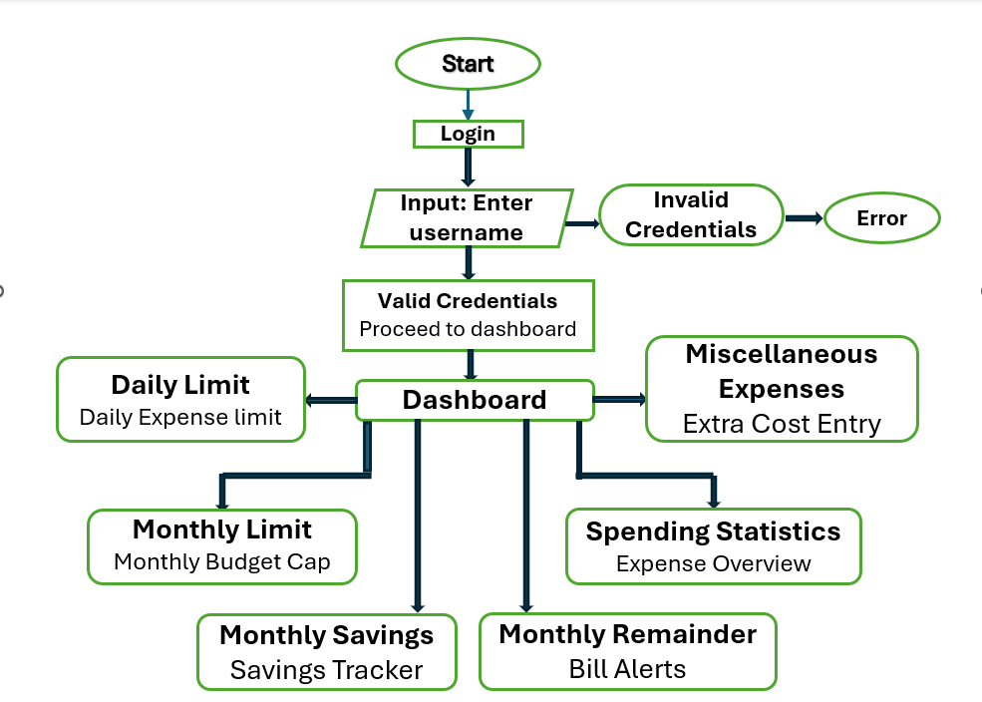

Fig 1: Flow chart of the website

4.1 System Planning and Design

Initially, the requirements were gathered based on common user challenges in financial planning and tracking. The features included budget limits, daily tracking, reminders, and visual summaries. Similar systems such as SPENDWISE [1] and Android-based trackers [5][10] highlighted the importance of accessibility and user-friendly interface design in expense management platforms.

4.2 User Registration and Secure Login

The system starts with a simple login and registration process to ensure data privacy and user-based customization. This process is essential for protecting sensitive financial data, a priority in many personal finance systems [3][13].

4.3 Budget and Limit Setup

Users can define both monthly and daily limits. When an expense is recorded, the system checks these limits and triggers notifications if they are exceeded. This functionality aligns with research emphasizing the value of budget enforcement in digital systems [2][4][11].

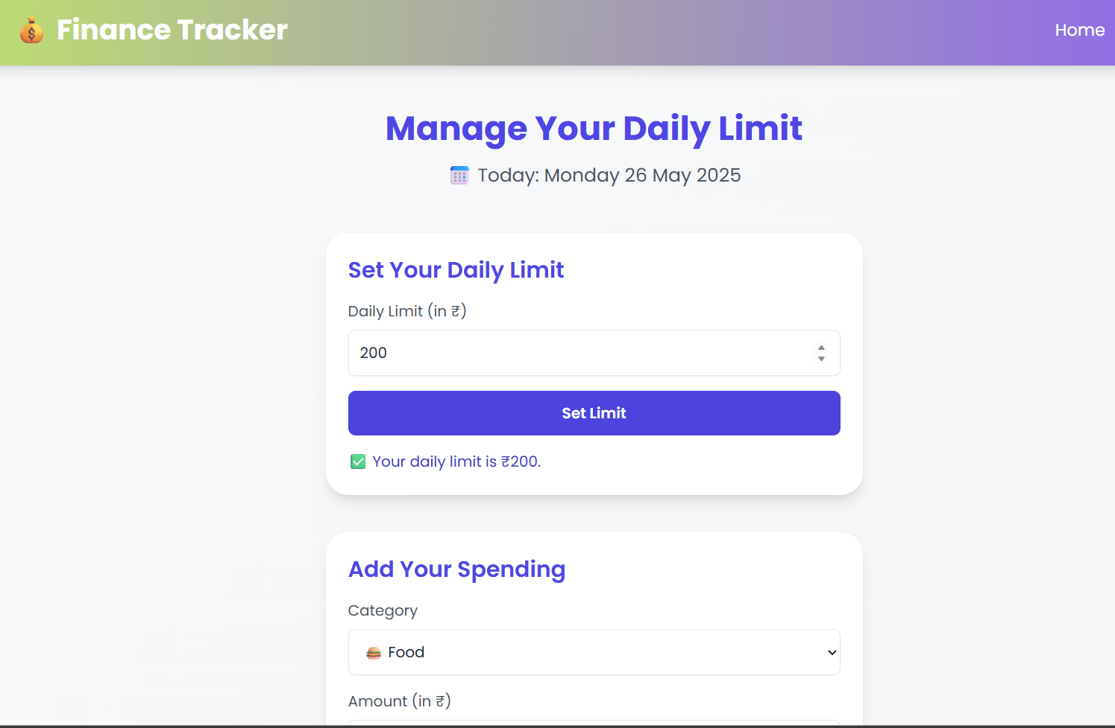

Fig 2: Daily limit manager

4.4 Expense Input and Categorization

Expenses are entered manually through the dashboard and automatically categorized into groups such as groceries, transport, bills, etc. Categorization supports pattern recognition and allows users to analyze where most of their income is being spent, a strategy discussed in multiple implementations [6][9][14].

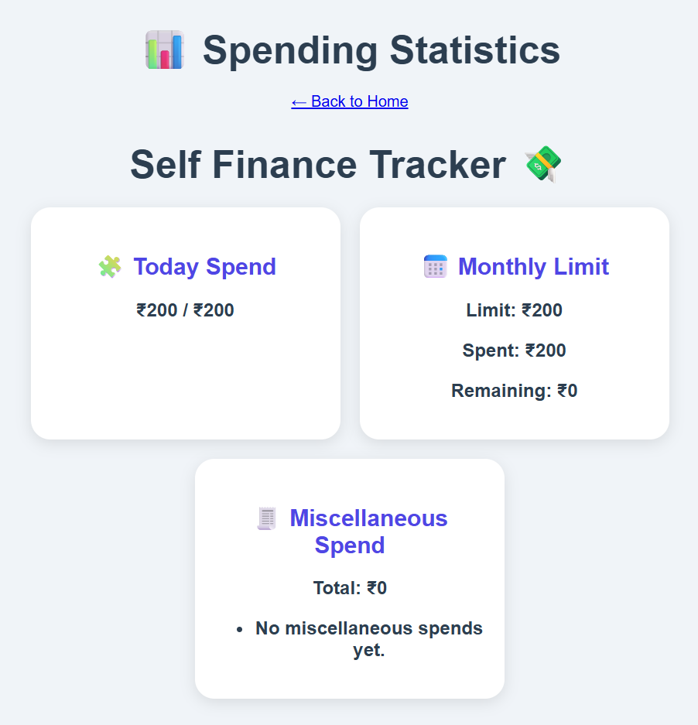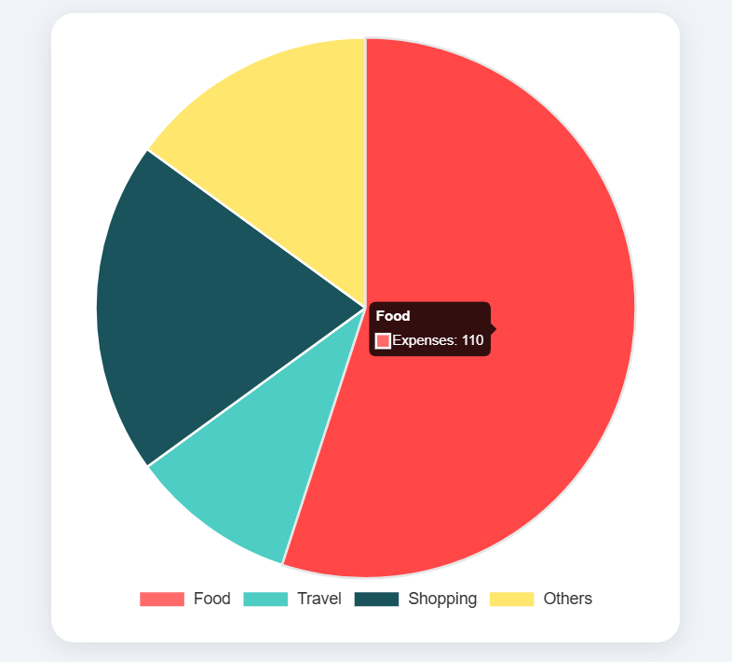

Fig 3: Spending statistics

4.5 Reminders and Alerts

To help users stay on top of their spending, the system generates reminders for recurring bills and daily expenditure summaries. Alerts based on thresholds also help prevent overspending. Studies show that such nudges are effective in increasing financial awareness [7][16].

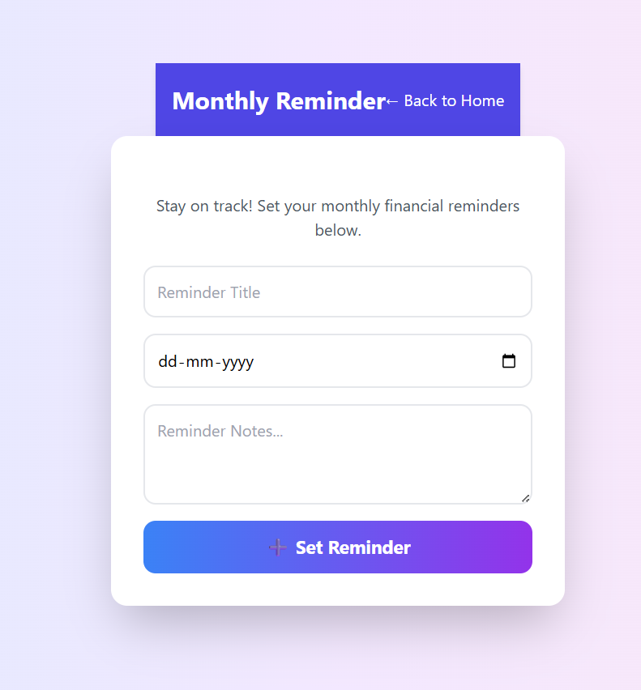

Fig 4: Monthly remainder

4.6 Savings and Remainder Tracking

At the end of each month, the system calculates savings as the difference between the user's set budget and actual expenses. The remainder is displayed in the dashboard. Similar systems have shown that visual savings feedback motivates users toward more disciplined financial behavior [12][15][19]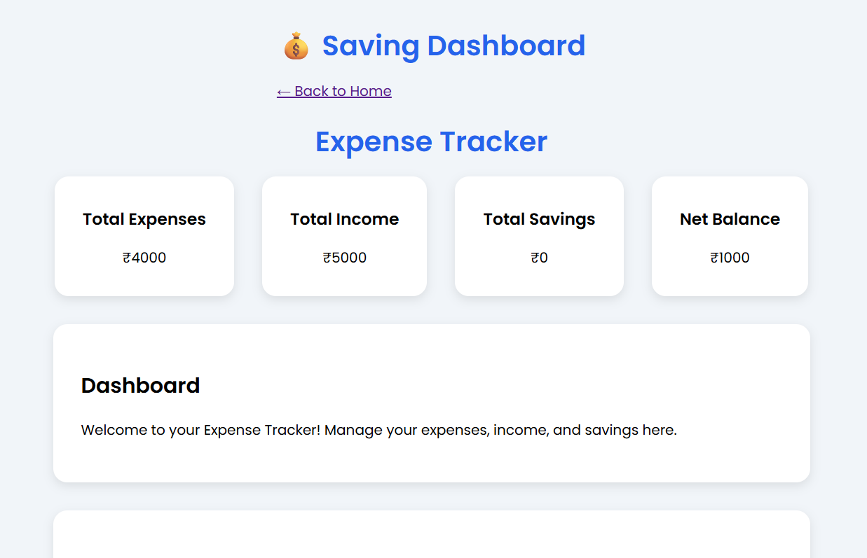

Fig 5: Savings Dashboard

.4.7 Visual Analytics and Dashboard

The dashboard is designed to be clean and informative, using bar graphs and pie charts to show category-wise spending and savings trends. Research has shown that visual representation of personal financial data significantly improves user understanding and engagement [8][17][20].

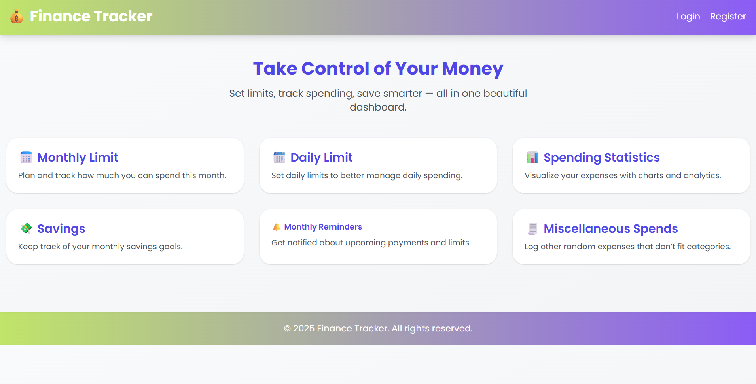

Fig 6: Dashboard Interface

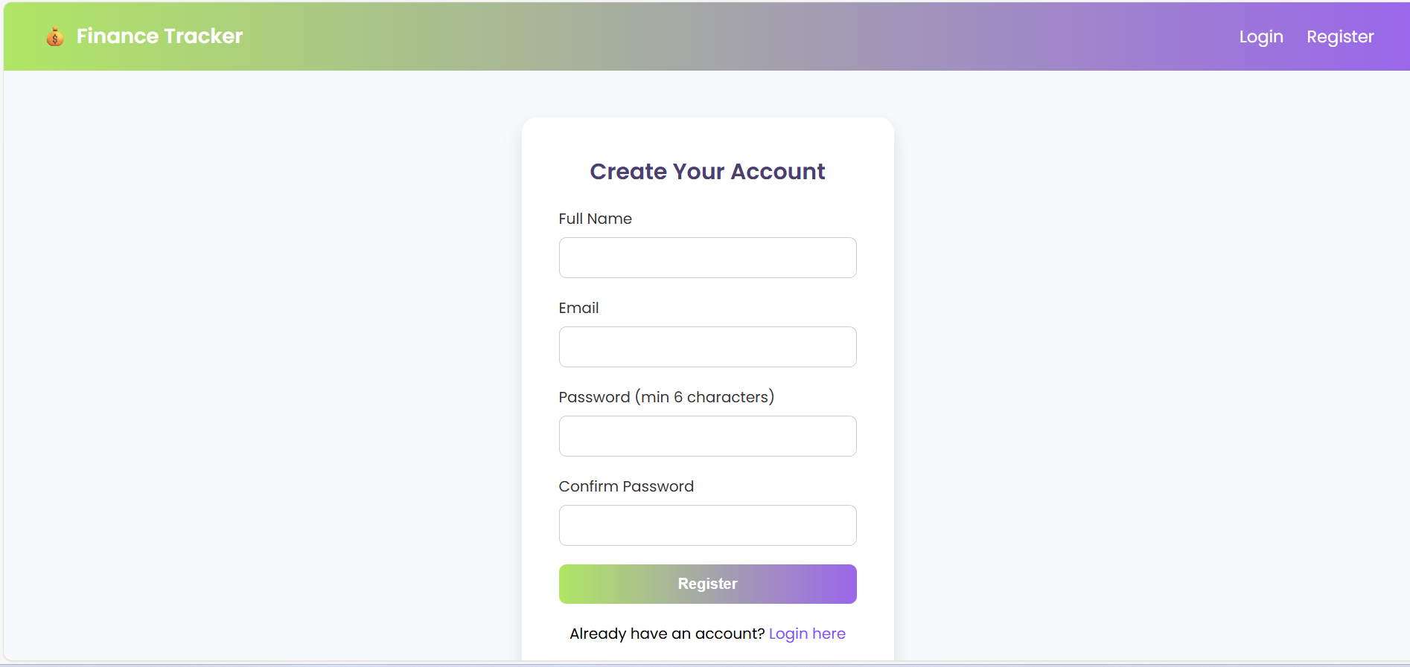4.8 Testing and Feedback Integration

The application underwent module-wise testing to ensure proper functioning of login, budget setting, reminders, and analytics features. Feedback from users helped refine the interface and functionality. This user feedback loop is consistent with modern development practices outlined in studies on financial app usability [18].

Results and Discussions

After developing the Self Finance Tracking System, we conducted thorough internal testing to make sure all parts of the application worked as intended. Since the system is meant to help users manage their daily and monthly spending, our main focus during testing was on accuracy, reliability, and how smoothly different features worked together.

### 5.1 System Functionality

We tested each feature step by step. The login and registration process worked without any issues — it successfully verified user details and protected account data. Once logged in, users could easily set their daily and monthly spending limits. When we entered expenses that went over the limit, the system showed proper alerts and updated the dashboard.

We also tested how the system calculated savings at the end of the month. It correctly subtracted total expenses from the monthly budget and displayed the remaining amount. Expenses were grouped into categories like food, travel, and other items, and the totals for each category were shown clearly. Reminders for monthly bills or spending updates were also triggered at the right time.

This behavior is consistent with how similar systems like SPENDWISE [1] and mobile finance apps [5][10] function, focusing on the basics of finance tracking in a user-friendly format.

### 5.2 Performance on Different Devices

We opened the system on various devices and browsers, including mobile phones, tablets, and desktops. The pages loaded quickly, the layout adjusted well to different screen sizes, and all calculations and visuals worked without errors. The charts and graphs updated instantly when new expenses were added, giving users an immediate overview of their spending habits.

These results suggest the system is stable and performs reliably, in line with performance expectations of modern finance tools [8][14].

### 5.3 Simulated User Scenarios

Although we didn’t collect real user feedback, we ran simulations to see how the system would behave in everyday situations. We created a sample profile and entered expenses over a 30-day period, including small daily costs and a few larger ones like rent or bills. The system responded just as expected: it tracked daily totals, alerted us when we crossed spending limits, and displayed savings at the end of the month. Pie charts and bar graphs gave a clear view of which categories had the highest spending. as shown in past studies [4][13][19].

### 5.4 Observed Limitations

While the system worked well for basic finance tracking, we also noticed a few areas for improvement. Right now, all expenses have to be entered manually. There’s no support for uploading bills, scanning receipts, or syncing with bank accounts. Also, reminders are fixed and cannot be customized for specific dates or times.

Advanced features like automated data entry or AI-based predictions — found in other systems [7][11][15] — were not part of this version, as our focus was to keep things simple and easy to use.

### 5.5 How This System Compares

Compared to more complex applications like Mobile Bookkeeper [11] or MoneyWise [18], our system is lighter and more focused on essentials. It doesn't depend on third-party platforms or cloud-based services. This makes it a good option for students or individuals who want a clean, straightforward way to keep track of their spending.

Future Scope

To further enhance the functionality and usability of the tool, some areas of future development may consider:

* Local Storage or IndexedDB Integration: Persist transaction data across sessions without needing to have a backend.
* Income vs. Expense Comparison Dashboards: Utilize bar chart and savings indicator to make financial information more apparent.
* Receipt Scanning with OCR: Apply text extraction from receipt scanning using JavaScript libraries such as Tesseract.js, motivated by Firebase-based mobile applications.
* Dark Mode Toggle & Theme Customization: Include user-friendly themes to enhance accessibility and user satisfaction.
* User Feedback Option: Include a feedback element in the app to garner user input, bug reports, and satisfaction. This will allow for ongoing improvement by linking future updates to real user needs.

# Conclusion

Effective deployment of an interactive and lightweight expense monitoring application proves the usability and feasibility of using purely front-end web technology—HTML, CSS, and JavaScript—to solve real-world problems such as personal finance management [8]. Through the use of interactive pie charts and keeping the system interface clean and user-friendly, the system encourages people to regularly track their spending without being inundated [9]. In contrast to AI-based trackers relying on server-side infrastructure, this approach provides seamless deployment using sites like GitHub Pages and respects user privacy by storing all information locally. These decisions fit into the trend toward developing simple yet effective tools specific to students and early technology adopters of financial restraint.

Acknowledgment

We would like to take this opportunity to thank all those who helped us in the successful execution of our project. To begin with, we would like to thank our guide **APARNA NIRANJAN SHENDKAR** **MA’AM** from the bottom of our hearts for their valuable guidance, constant encouragement, and valuable suggestions during the project. Their advice and motivation have played a vital role in guiding our knowledge and sharpening our work. We also acknowledge our gratitude to our institution **Vishwakarma Institute of Technology , Pune** and the faculty members for giving us the required resources, information, and a good learning environment. A special appreciation to our team members for their hard work, cooperation, and determination in overcoming obstacles and successfully executing the project. Finally, we appreciate our family and friends for their support and motivation throughout this experience.This project has been an excellent learning experience, and we appreciate being able to delve into and apply our technical knowledge in a real-world context.

References

1. N. G. Dharaniya, A. Kumar, and P. Jeycharan, "SPENDWISE - Smart Expense Tracking and Management System," International Journal of Progressive Research in Engineering Management and Science (IJPREMS), vol. 5, no. 5, pp. 320–323, May 2025.
2. N. Mohol, A. H. Auti, N. Nelekar, O. Kolate, and A. Nishad, "AI Expense Tracker," International Research Journal of Modernization in Engineering, Technology and Science (IRJMETS), vol. 7, no. 4, Apr. 2025. [Online].
3. R. Mahdi, "Personal Expences Tracker," Research Proposal, Methodist University, Oct. 2024. [Online].
4. C. K. Gomathy, "Expenditure Management System," ResearchGate, May 2022. [Online].
5. Adepegba, O. A., Fayemiwo, M. A., Oduwole, O. A., & Onamade, A. A. (2019). An Android Based Mobile Application for Tracking Daily Expenses. In Proceedings of the 21st iSTEAMS Multidisciplinary GoingGlobal Conference, CSIR-INSTI, Ghana & University of Ghana, Legon.
6. Victoire, A., Karunamurthy, A., & Kiruthivasan, R. (2024). Creating Robust Expense Tracker Applications with Flutter: A Step-by-Step Guide. International Journal of Innovative Science and Research Technology, 9(4), 1546–1553
7. Harsshita, S., Shruthi, A., Srinidhi, B. K., & Sandhya, A. (2024). Advanced Personal Budget Analytics: Combining Optical Character Recognition and Natural Language Processing for Automated Budget Categorization and Insight Extraction. International Research Journal on Advanced Engineering Hub (IRJAEH), 2(10), 2463–2469
8. Dadhich, A., Jain, S., Jain, S., & Mathur, S. (2023). Expense Tracker. International Journal of Research and Analytical Reviews (IJRAR), 10(2), 777–779.
9. Stefanov, T., Stefanova, M., Varbanova, S., & Temelkov, S. (2024). Personal Finance Management Application. TEM Journal, 13(3), 2066–2075
10. Makalew, B. A. (2022). Android Based Personal Finance Management Application: Design and Development. Jurnal EMACS (Engineering, Mathematics and Computer Science), 4(1), 5–9.
11. M. B. Garcia and J. P. Claour, "Mobile Bookkeeper: Personal Financial Management Application with Receipt Scanner Using Optical Character Recognition," in Proc. 1st Conf. on Online Teaching for Mobile Education (OT4ME), Dec. 2021. DOI: 10.1109/OT4ME53559.2021.9638794.
12. Kaye, J., McCuistion, M., Gulotta, R., & Shamma, D. A. (2014). Money talks: Tracking personal finances. In Proceedings of the SIGCHI Conference on Human Factors in Computing Systems (pp. 521–530). ACM.
13. R. Qian, "Management of Personal Finances and Investment Decisions," in Proc. 2nd Int. Conf. on Financial Technology and Business Analysis, 2023. DOI: 10.54254/2754-1169/64/20231532.
14. V. Kozhevnikov, A. Sergeev, and A. Bulavintsev, "Design and Development of Personal Finance Management System," Theor. Appl. Sci., no. 6(74), pp. 46–50, Jun. 2019. DOI: 10.15863/TAS.2019.06.74.8.
15. H. Chen, S. Chen, and J. Zhao, "Integrated Design of Financial Self-Service Terminal Based on Artificial Intelligence Voice Interaction," Front. Psychol., vol. 13, Art. no. 850092, Mar. 2022. DOI: 10.3389/fpsyg.2022.850092.
16. V. Agarwal, R. Ray, and N. Varghese, "An AI-Powered Personal Finance Assistant: Enhancing Financial Literacy and Management," Presentation, Christ University, Mar. 2024. DOI: 10.13140/RG.2.2.10706.57280.
17. G. Bekaroo and S. Sunhaloo, "Intelligent Online Budget Tracker," in Proc. 2007 Computer Science and IT Education Conference, Oct. 2007.
18. P. V. Suryawanshi, "MoneyWise (A Personal Finance Tracker)," Parul University, Department of Computer Science and Engineering, Vadodara, Gujarat, India, 2023.
19. Y. Xie, "The Design and Implementation of Personal Finance Management System Based on Android," in Proc. 5th Int. Conf. on Computer Sciences and Automation Engineering (ICCSAE 2015), Atlantis Press, 2016.
20. Y. A. Alsehhhi, M. Abdelrazek, and A. Bonti, "Personal Data Visualisation on Mobile Devices: A Systematic Literature Review," Deakin University, 2022.

1.